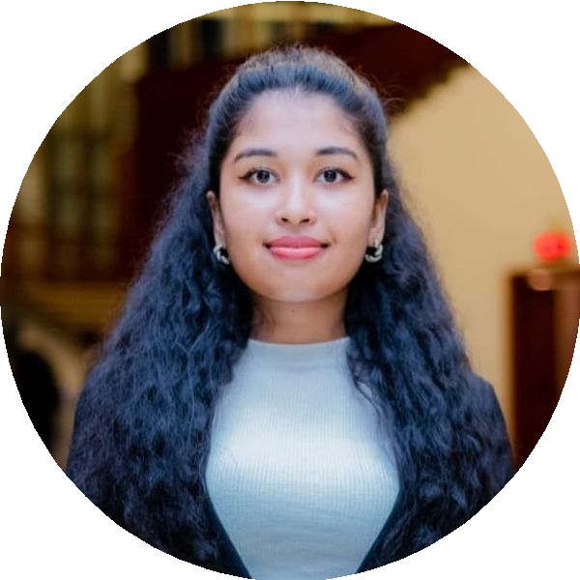
THARUKA HEENKENDA
Degree complete - BSc (Hons) Biotechnology
+94759727769
t.heenkenda2000@gmail.com
No25, Sathuta, Jayawardana Lana, Egodauyana, Moratuwa.
linkedin.com/in/tharuka heenkenda-823544284
Profile
Detail-oriented and professional with a strong background in Chemistry, Biotechnology, and cosmetic science, complemented by experience in research, quality assurance, regulatory compliance, and product development. Seeking an opportunity within the cosmetics industry to apply my scientific knowledge, innovative thinking, and analytical skills toward developing safe, effective, and high-quality cosmetic products. Proven ability to support laboratory operations, coordinate projects, ensure compliance with industry standards, and contribute to continuous improvement and organizational growth.
Professional Experience

Lab Assistant at Neerogya Health Care

Trainee Horticultural Research and development, Gannoruwa Training period- three and half month (14 weeks) (10/12/2024 – 25/03/2025) During this period, Training was conducted in 5 Division in HORDI.

Plant Pathology Division:
  - Participated in activities related to the identification of new plant diseases.
  - Gained exposure to molecular techniques used for the confirmation of plant pathogens.

Entomology Division:
  - Gained experience in the collection and/or preservation of insect specimens.

Soil Microbiology and Plant Nutrition Division:
  - Assisted in the testing of micro-nutrient levels in plant samples.
  - Contributed to research efforts in soil fertility, plant nutrient management, soil physics, and/or soil microbiology.

Central Analytical Laboratory:
  - Participated in pesticide residue analysis in various food items (fruits, vegetables, rice, water).
  - Assisted with elemental analysis of food items (fruits, vegetables, rice, water).

Research student
About chemical compositions at General Chemistry Laboratory, Molecular Laboratory, and Microbiology Laboratory.
Prior experience with chemical sample testing and analyzing Prior experience in high-tech laboratory equipment handling in the General Chemistry Laboratory and Molecular Laboratory.
12/2025 – Present
Polonnaruwa

12/2024 – 03/2025
Kandy

2022 – 2023
Horizon Campus,
Malabe
2022 – 2024
Horizon Campus,
Malabe

Prior experience in maintaining lab equipment, sterilizing lab equipment, and developing non-standing chemical tests (2 years) Prior experience in writing tests (laboratory experiments) and reports (2 years)
2022 – 2024
Horizon Campus,
Malabe

Research
My undergraduate research focused on the development of novel skincare formulations utilizing rice bran, involving the creation of different cream formulations and their comprehensive physiochemical evaluation (pH, emulsion type, viscosity, spread ability, acid value, peroxide value, and centrifugation stability). Furthermore, I conducted qualitative phytochemical screening to understand the potential bioactive components. Eager to contribute my research skills and passion for sustainable product development in a dynamic industrial setting
Education

BSc (Hons) Biotechnology
HORIZON Campus
(Main Subjects: General Chemistry, Introduction to Bioprocess Engineering, Organic Chemistry, Environmental Biotechnology, Industrial Microbiology, Research Methods and Design, Innovation and Commercialization, Statistics, Principal of Management, Foundation of Business)

Diploma in Ayurvedic Cosmetics manufacturing
Asian Institute of Keraleeya Ayurveda

Quality Management, Great Learning,(6 Month)
Horizon Campus

A comprehensive workshop on Tools & Techniques for Quality improvement for the fourth-year undergraduate students Horizon Campus
Diploma in Information and Communication Technology
SIBA Campus

Diploma in English
SIBA Campus

G.C.E. Advanced Level
CP/HK/Denike Secondary School

G.C.E. Ordinary Level
CP/HK/Denike Secondary School
2021 – 2025
Malabe

2025
Rajagiriya
2024
Malabe
2024
Malabe

2020
Kandy
2020
Kandy 2019

2016

Skills

Cell culture
Microscopy
Clinical Testing Data Entry Documentation
Analytical techniques
Specimen Collection & Handling
Aseptic Technique
Laboratory Instrumentation

Interests

  - MS Office Suite
  - Time Management
  - Project Management
  - Leadership
  - Public Relations
  - Critical Thinking

Extra Curricular Activities

Brand partner of Oriflame
Cosmetics Company (Sweden product)

Director of Social and international
LEO club of Horizon Campus

Heads of Science Faculty at student council
Horizon Campus

Director of Fundraising at student council
Horizon Campus

Former Director of Editorial committee
Student Council Of Horizon Campus

Former Director of Event management and operations
Student Council Of Horizon Campus

Prefect at Secondary School
Denike Secondary School

President of the Sinhala literacy association
Denike Secondary School

2024 – 2025

2024 – 2025

2024 – 2025

2022 – 2023

2022 – 2023

2016 – 2017

2016 – 2017

VOLUNTEER EXPERIENCE

Horizon Campus ORATIO ʻ24 | 2024
Horizon Campus Research Symposium | 2023
Horizon Campus South Asian Conference On Higher Legal Education and Sustainable Development | 2023
Languages
Sinhala English
References
Ms. Danushika Nayomi, Lecturer/Faculty of Science Advisor/ Rotaract Club, Horizon Campus. danushika@horizoncampus.edu.lk, +94713428785
Dr. Eranga Karunarathne, Acting Dean, Faculty of Science, Horizon Campus, Malabe ekarunarathne@horizoncampus.edu.lk, +94 776506278

Declaration
I hereby declare that all the information provided in this CV is true, complete, and accurate to the best of my knowledge. I understand that any false or misleading information provided may result in the rejection of my application or termination of employment if discovered after employment.
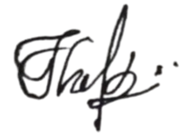

THARUKA HEENKENDA

